########################################################

Kubernetes Version 1.14

Category: Troubleshooting; - Namespace stuck in Terminating state, after delete.

Author: Picky Butani; Reviewer:

Document Owner: HHSC – Austin, TX

References: <https://success.docker.com/article/kubernetes-namespace-stuck-in-terminating>

########################################################################

Removed Namespaces from Terminating state.

Find all namespace in cluster.

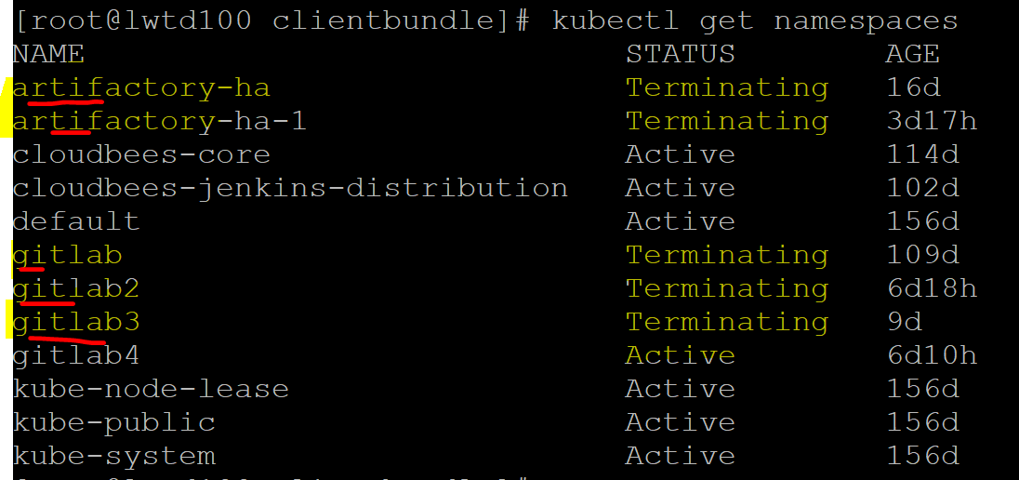

Find which resources in namespace is not getting removed:

kubectl api-resources --verbs=list --namespaced -o name | xargs -n 1 kubectl get -n namespace artifactory-ha

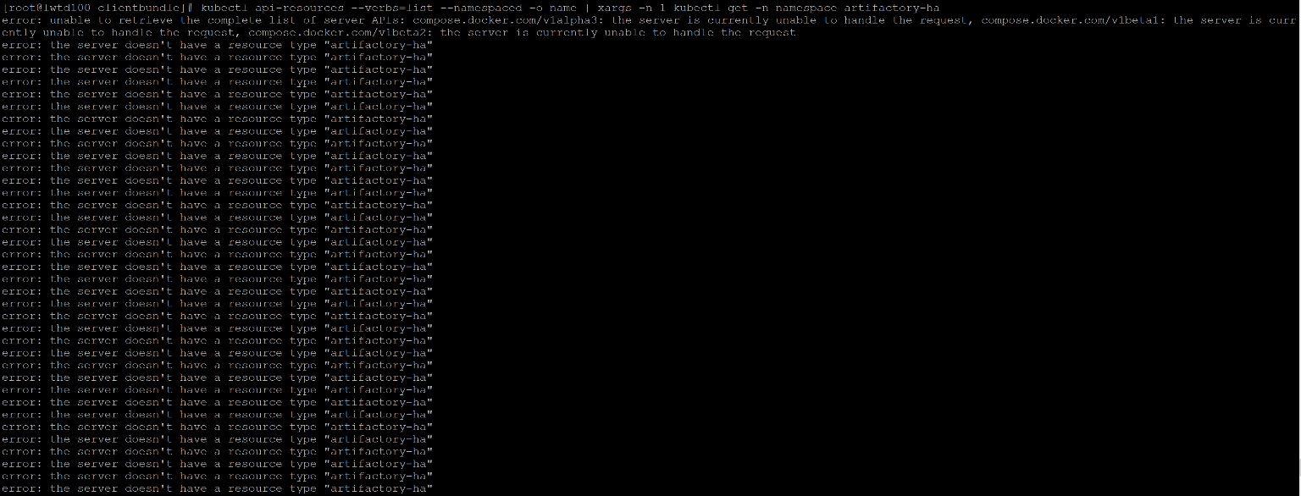

Check is there any apiservice in false state, not working.

kubectl get apiservice | grep False



We have to remove manually that resource.

Find where is this resource stuck. Above screen shows resource stuck is in default kubernetes system(kube-system) namespace.

Kubectl get namespace kube-system.

Verify Age of namespace and service stuck age. Here it is same 156days



Check which pods in that namespace stuck.

Kubectl get pods –namespace kube-system

Found compose-api is in error and it’s not able to restart itself, after 5785 attempts.

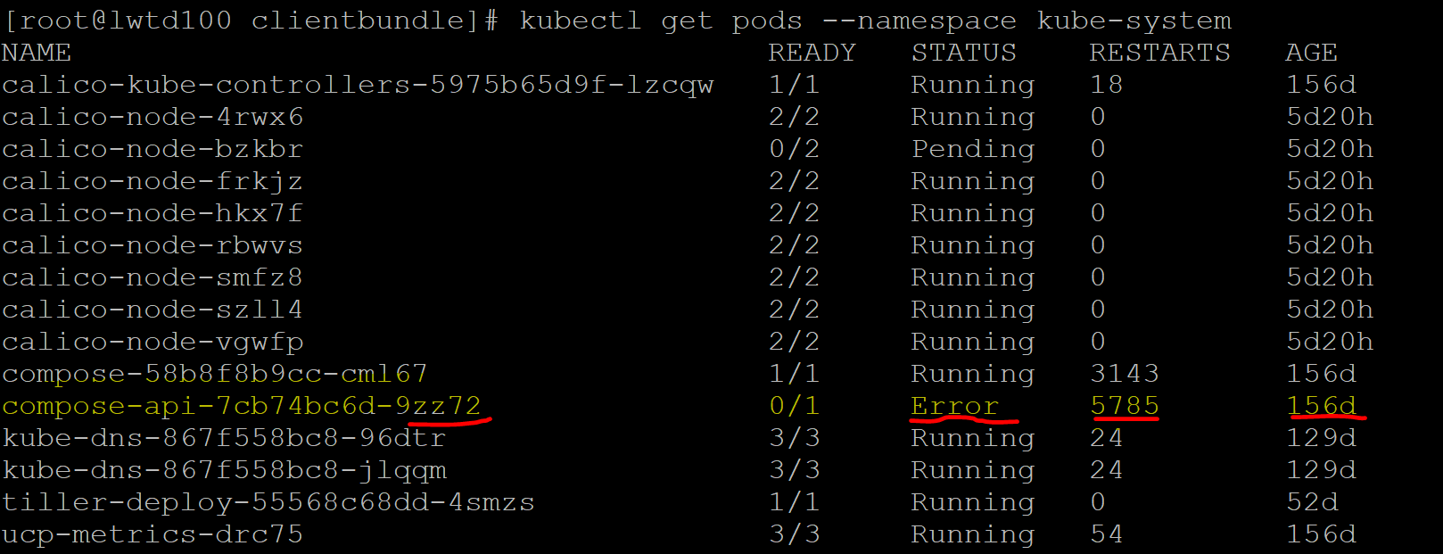

Don’t try to remove pods directly until you find its respective deployment name.

Kubectl get deployment -n=kube-system

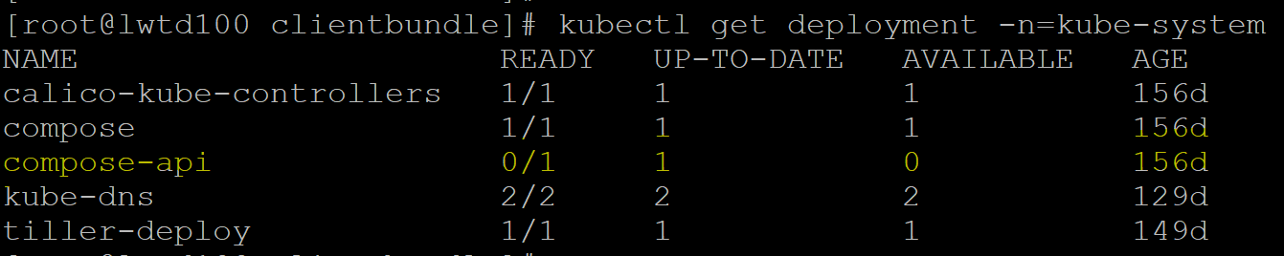

We can try removing pod individually if its stuck in custom deployment, but as we found its system pod/deployment. Kubernetes will install and deploy again automatically.

Now remove deployment for that resouce:

Kubectl delete deployment compose-api –namespace=kube-system



Verify the pods are removed. You can see it would be terminating or removed

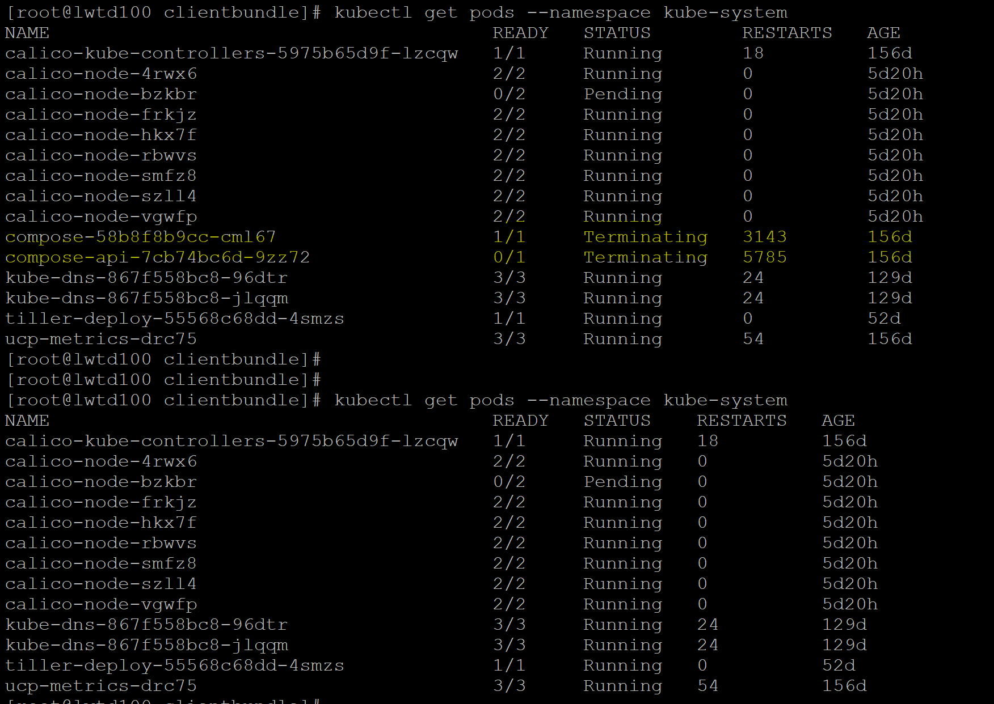

Now you can see that pod is getting created again.

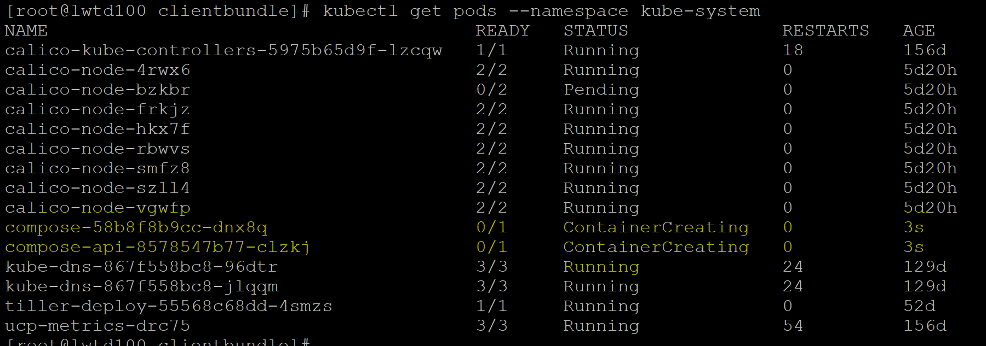

Even you can confirm deployment is recreated.

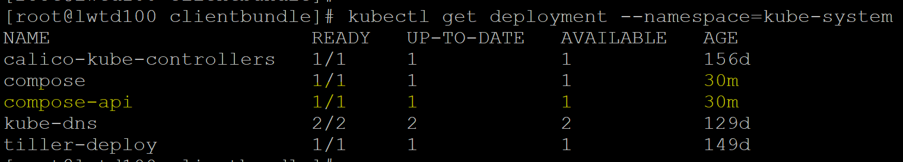

Now those pods are running. No Error state.

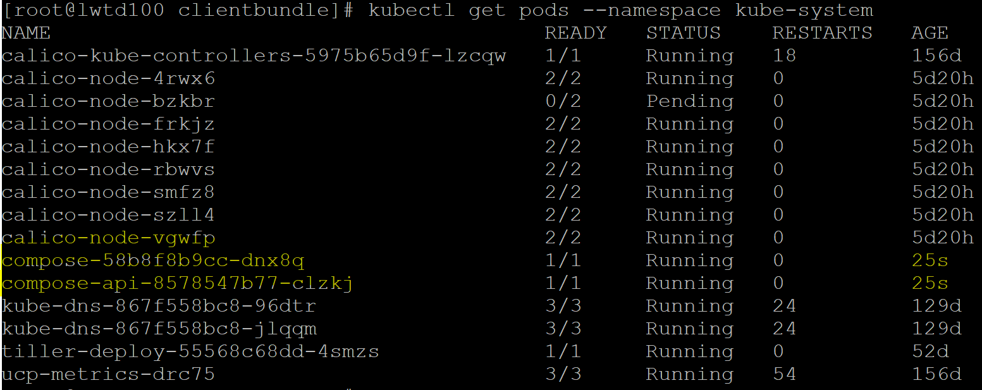

Note : Wait for 5 minutes for engine to re-scan and restart. Now we can see namespaces in Terminating state are removed.

Now you can see no more namespaces in Terminating state.

